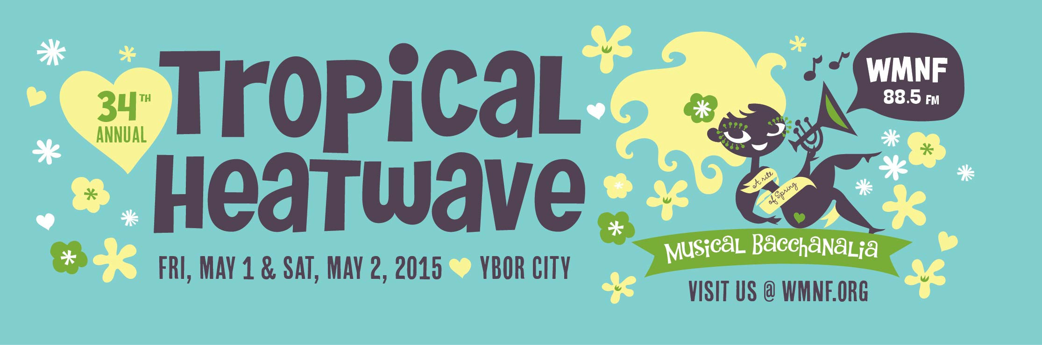

Food Vendor Fee/Refundable Deposit
Each 10 x 10 Food Vendor space cost is $600 for two days which includes a $100 refundable deposit that is refunded within 30 days if you comply with the rules below.
Each 10 x 20 space or Food Truck is $800 for two days which includes a $100 refundable deposit that is refunded within 30 days if comply with the rules below:
1. Each Food Vendor is responsible for leaving their assigned space clean and clear of any debris. Please dispose of all your trash in appropriate trash receptacles. All food vendors must also take all of their own refuse (such as oil/grease, charcoal, etc.) off of the premises at the end of the Event.
2. The vendor area must be completely cleared of all by 2:00 AM Saturday night. All vendors must load up, clean assigned space of any debris and leave the area by 2:00 AM. Any additional charges imposed on WMNF will be passed on to those vendors that do not comply. All Food Vendors must remain open during all scheduled hours of this event. Please do not break down your display before 12:00 AM.
Assignment of Space
The Food Vendor spaces will be located inside the Cuban Club/El Pasaje courtyard. The location of each vendor is assigned by WMNF. Each space is measured and clearly marked with the vendor’s name on the morning of the event. Food Vendor acknowledges that this is an outdoor location and will make no claim against WMNF if the event is cancelled, delayed or curtailed because of weather. Please be advised that WMNF is not providing a rain contingency.
Insurance/License Requirements
Participating Food Vendors must be licensed by the State of Florida. A copy of the license and proof of a $1,000,000 liability policy naming WMNF and the City of Tampa as additional insured must be provided with payment on accepted applications, no later than April 22, 2015 to:
Anne Heywood c/o WMNF - 1210 E. Martin Luther King Jr. Blvd - Tampa, Florida 33603-4449
Use of Space
*Food Vendors may NOT sell any drinks, including but not limited to water, beer or alcohol. (Water will be sold exclusively by WMNF as part of its fund-raising efforts connected with this event.) Food Vendors must be totally self-contained and supply all necessary display/sale items, such as tables, chairs, decorations, garbage disposal, ice, etc. Tents used must have a label indicating that it is flame retardant. Heavy duty garbage bags must be used for disposal in designated area.

(Use of Space cont’d)
* Vendors must provide their own signage including business name, items for sale and prices.
*Vendors must provide their own generator or electricity source, and their own water. Water is very limited.
*Food Vendor spaces must be kept clean at all times. Please comply with all health department regulations. Vendor’s license must be posted at Vendor’s booth or cart.
*WMNF does not provide a tent or covered area for vendors.
Application Process/Payment
Please email Anne at AnneH@wmnf.orgto discuss details prior to submitting this Agreement and Application. Julie Scheid can also assist with any questions or concerns you might have. You can reach her at MissJulie@wmnf.org Applications are due no later than April 22, 2015. Payment is due upon acceptance of the application by WMNF. Payments may be made by VISA or Mastercard credit or debit cards, check, or money order.
Make check or money order payable to WMNF and indicate on your check or money order that the payment is for the 2015 WMNF Tropical Heatwave Food Vendor Space Fee. *** No refunds will be issued by WMNF***
This application is not binding. Your space will only be guaranteed when your application has been reviewed and accepted by WMNF and your payment has been received by WMNF. Space is limited.
Vendor Set Up & Tear Down/Parking
The courtyard will be available for Food Vendor set up at approximately 11:00 AM on Friday, May 1. All setup must be completed by 3:00 PM. You can enter through the entrance on E. 9th Avenue, immediately east of 13th St. After unloading, please move your vehicle as soon as possible from the street so that other people trying to set up can have access. There is parking in the public garage located at 2010 N.13th St. You are responsible for your parking fees.
Safety/Security
Vendor is responsible for the security of Vendor’s space and the material within Vendor’s space and assumes all responsibility for all goods, materials, exhibits, displays, articles and other tangible personal property before, during or after the Event and the Event assumes no responsibility for said items.
Vendor’s display should be arranged so that it will allow for safe aisle space and not impede the flow of foot traffic in, past, or around the display area, as determined by WMNF and/or the City of Tampa Fire Marshall.
Vendor shall be responsible for the public safety, health and welfare of your patrons, agents, vendors, sub-contractors, concessionaires and employees. Safety of all guests, vendors, and exhibitors is of utmost concern. Any and all unsafe conditions or activities will be brought to the attention of the responsible parties and corrective measures are to be made immediately. Vendor is responsible for (and agrees to pay all costs of repair or replacement for) any and all damages caused by Vendor, (or Vendor’s agents, vendors, sub-contractors, concessionaires and employees) to the Event area, which may have occurred during the term of the Event in the space occupied by the Vendor.

Miscellaneous
Each vendor gets 6 admissions to the Cuban Club area for the event. Please contact Julie Scheid at MissJulie@wmnf.org if you will need more than that. Vendors can purchase tickets to the entire event, and that information can also be provided by Julie.
The Event reserves the unilateral right to cause the interruption of the Event in the interest of public safety (or any other reason it deems necessary) and to likewise cause the termination of such Event when, in the sole and arbitrary judgment of any County, State or Federal agency or its agents, including but not limited to the City of Tampa, Health Department or Fire Department, such action is necessary in the interest of public safety, health and welfare.
Participating Food Vendors give WMNF; its employees, agents, and assigns permission to use submitted images of their display and/or menu items for promotional purposes of the WMNF Tropical Heatwave that they are participating in.
The collection of sales tax and payment to the Florida Department of Revenue will be the sole responsibility of each individual Food Vendor.
Failure to comply with these rules may result in your dismissal from this event.
WMNF reserves the right to refuse an application if it is deemed inappropriate for this event.
Thank you for your cooperation and for your interest in participating in this WMNF fundraising event.
Please contact WMNF’s Anne Heywood at AnneH@WMNF.org to discuss details about your participation in the event.

