The Nathan B. Stubblefield Foundation, Inc.

Board Meeting Minutes of October 24, 2011

Board Member | P | A | Board Member | P | A
 |  |  | Richard Manning | P
Mercedes Skelton | P |  | Rick Hurley | P
Todd Bray | P |  | Ryan Iacovacci | P
 |  |  | Lou Putney | P
Scott Elliott | P |  | Bill Roberto | P
Jeff Harris | P |  | Barry Shalinsky | P
Nancy Johnson | P |  | Dana Gilmore | P
Beth Bell | P |  | Leticia Valdes | P

- Call to Order – Letty Valdes – 6:58 pm.

- Roll Call/Proxies/Agenda Review – Letty Valdes:

- Interviews of BOD Applicants:
- Zachary Corral (Youth)
- Kurt Madsen
- Lorraine Thomas
- Rachel O’Connor (Youth)

Lou, Letty, and Richard expressed interest in returning for another term.
Motion to retain: Nancy / 2nd: Rick. Motion passed unanimously.

Open seats: One community, and one youth.
- After discussion, Motion to elect Rachel O’Conner to the Youth seat: Lou / 2nd: Scott. Motion passed unanimously.
- After discussion, Motion to elect Kurt Madsen to the community-at-large seat: Richard / 2nd: Rick. Motion passed 11 - 1.

- Visitors' Comments –Bill Hamilton was present: No comments.

- Review Last Month’s Minutes – Jeff Harris: Motion for approval of the regular September 2011 Board of Directors (BOD) Meeting Minutes. Motion passed unanimously. Motion: Richard / 2^{nd:} Todd.

- Consent Agenda – Letty Valdes: There were no Consent Agenda items.

- President’s Report/Executive Committee Report – Letty Valdes: Thank you to the staff for their help during our station manager transition.

- Station Manager Report – Mercedes: Written report in Appendix A. Discussion ensued about new audience research tool from Arbritron. Matt Cowley came and answered the Board’s questions about the new website design, the iPhone app, and other related items. The Board expressed their frustration with the pace of these projects.

- Finance Committee report – Todd Bray: No report.

- Personnel Committee – Rick Hurley: No report.

- Long Range Planning – Jeff Harris: No report.

- Community Advisory Council (CAC) – Barry Shalinsky: No report.

- Volunteer Committee – Bill Roberto: Application until Nov. 4 members elected before next meeting.

- Bylaws – Richard Manning: No Report.

- Nominating Committee – Ryan Iacovacci: BOD elections were held tonight.

- Development Committee – Nancy Johnson: Started to work on golf tournament.

- Diversity Committee – Bill Roberto: No report.

- Old Business / Follow-up:
- Website redesign – Ryan Iacovacci: No report.

- Under-30 group– Ryan Iacovacci: HY-C is continuing with help from Mercedes, Sheila. Outreach activities continue with live broadcasts.

- New Business:
a) Motion to re-engage Phil Scheidt as our CPA: Motion passed unanimously. Motion: Richard / 2nd Todd.
b) Bank resolution letter to remove Jim Bennett from a signer on our checking account.
c) Motion to allow Phil Scheidt to use our name in an article for the Journal of Accountancy. (See Appendix B) Motion passed unanimously. Motion: Lou / Richard
d) Ad-hoc Station manager Search committee. Barry will lead. Suggestions to change the job description should be submitted very soon.
e) RNC Committee – Written report included in Appendix C.

19. Attendance Review – Jeff Harris: All Board members are in good standing

20. Evaluation – Barry Shalinsky: Participation: 7.8
Accomplishments: 7.3
Listening: 7.75
Scheduling: 4.66

21. Adjournment – Letty Valdes: The Board meeting adjourned at 10:54 pm.

By:
Jeff Harris, Secretary

Approved by the Board on:

Appendix A

Appendix B

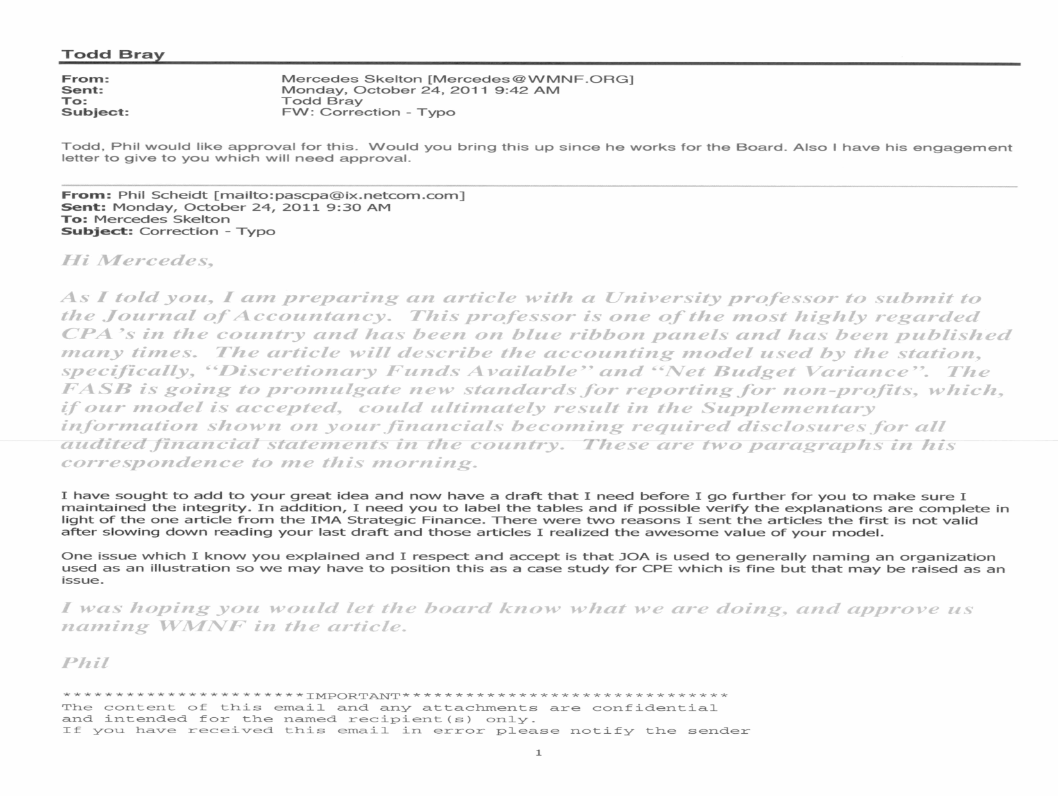

Appendix C



